**Docker Monitoring using promethues and Grafana**

1. **Create two ubuntu machines – Docker-server , Grafanamonitoring-machine**
2. **In both the machines**

**sudo su**

**apt update -y**

1. **In Grafanamachine I will install Grafana and in docker-server I will install docker and Prometheus**

**Grafana machine:**

wget <https://dl.grafana.com/enterprise/release/grafana-enterprise-8.4.4.linux-amd64.tar.gz>

ls

tar -zxvf grafana-enterprise-8.4.4.linux-amd64.tar.gz

ls

cd grafana-8.4.4

./bin/grafana-server

Grafana servers works on port 3000…so in security group enable port 3000

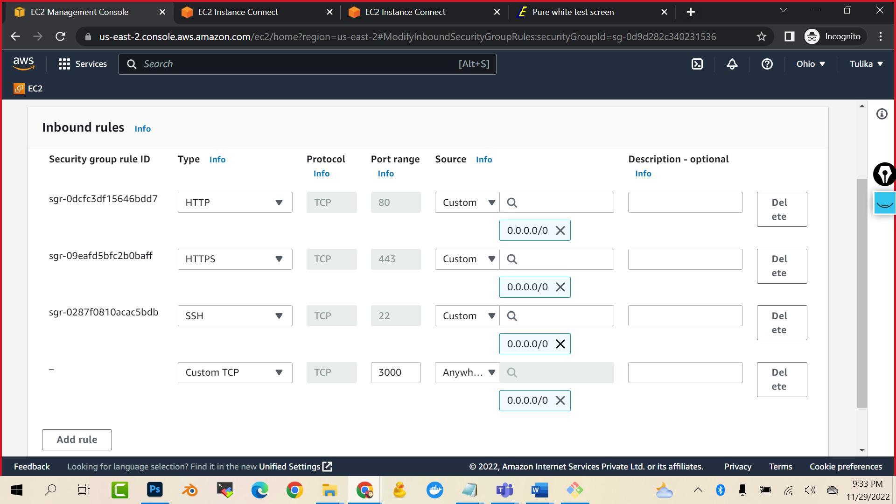

<<public ip>>:3000

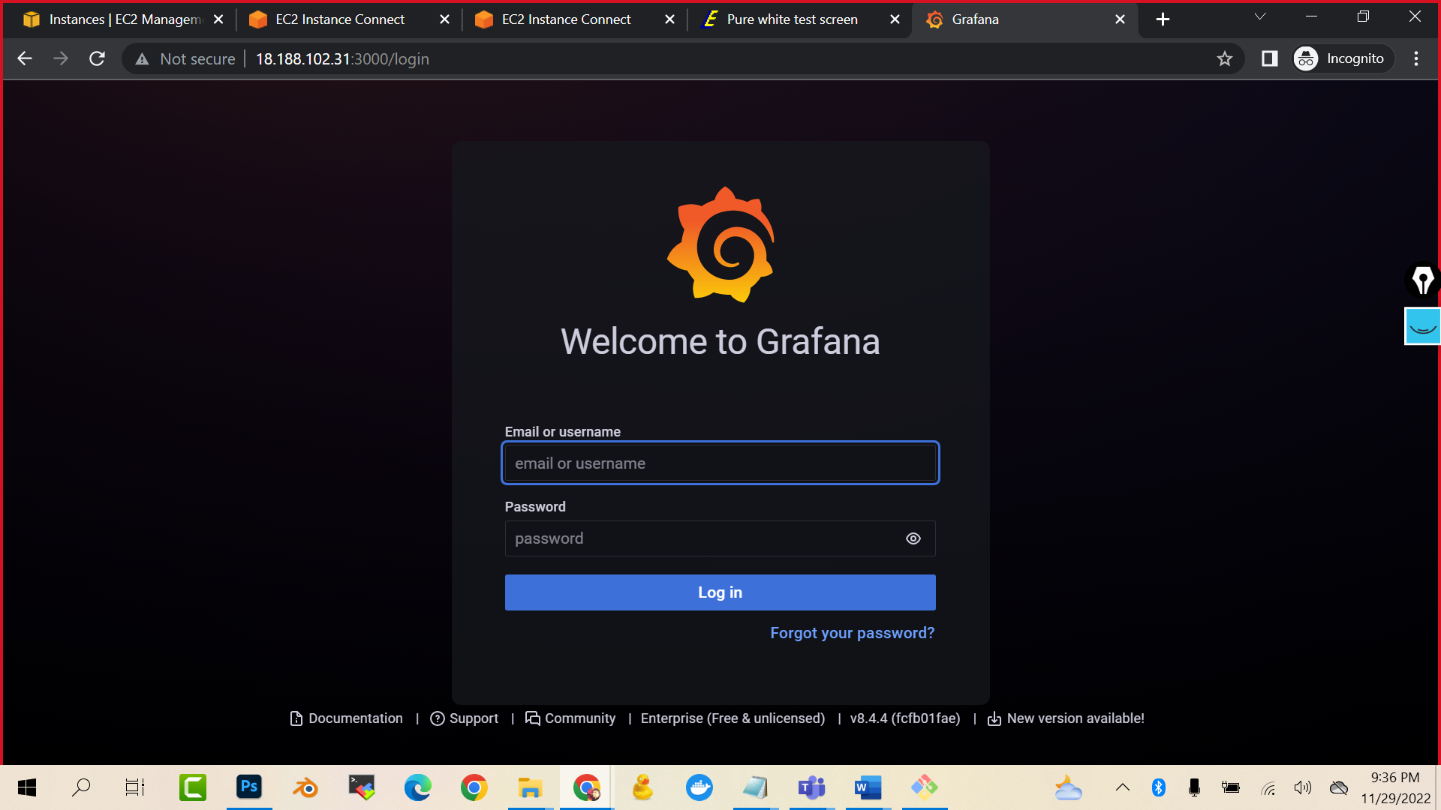

admin

pass: admin

#now lets setup the docker-server

apt install docker.io -y

service docker start

docker run -it --name c01 ubuntu /bin/bash

press ctrl p and ctrl q to come out of the container

docker run -it --name c02 ubuntu /bin/bash

press ctrl p and ctrl q to come out of the container

wget <https://github.com/prometheus/prometheus/releases/download/v2.34.0/prometheus-2.34.0.linux-amd64.tar.gz>

ls

tar zxvf prometheus-2.34.0.linux-amd64.tar.gz

ls

cd prometheus-2.34.0.linux-amd64

ls

##WE NEED TO TELL DOCKER AS WELL THAT PROMETHEUS WOULD BE TRACKING DOCKER VIA PORT 9323 port

vi /etc/docker/daemon.json

press I to insert{

"metrics-addr" : "0.0.0.0:9323",

"experimental" : true

}

To come out of this file press escape and :wq

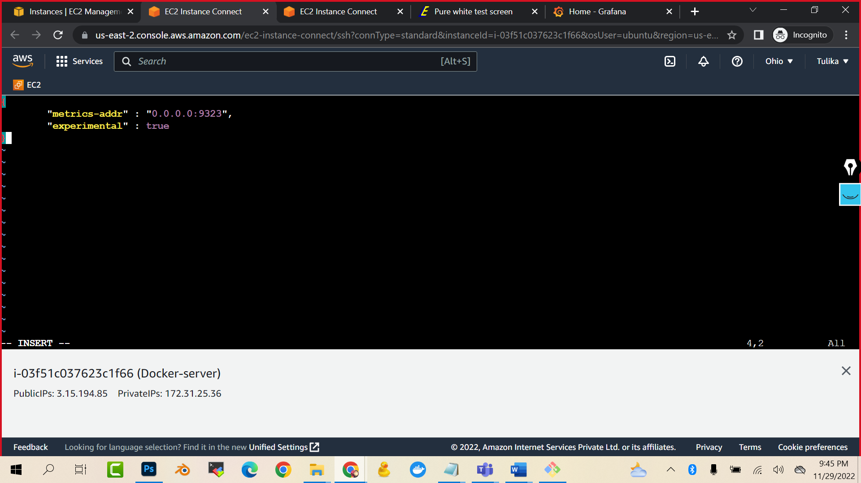

service docker restart

cd prometheus-2.34.0.linux-amd64

ls

(you will see Prometheus.yml file…it cont

ains all the configuration of Prometheus. Here we have to tell that metrics would be coming from port 9323)

Before that,  
go to docker-server machine and enable the port 9323 and port 9090

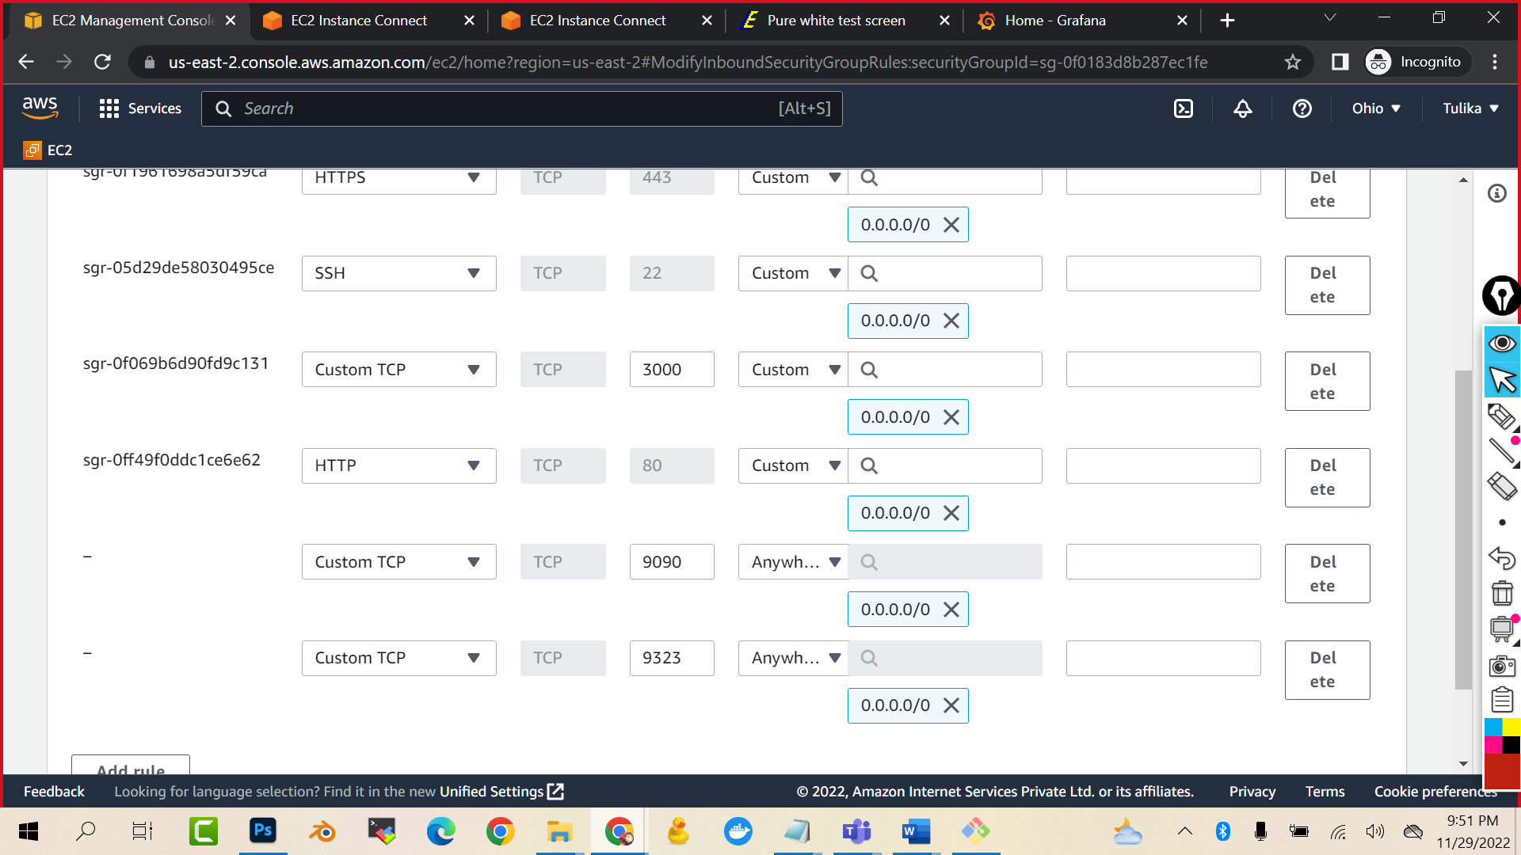

Copy the ip of machine and <http://3.15.194.85:9323/metrics>

You should see the docker stats

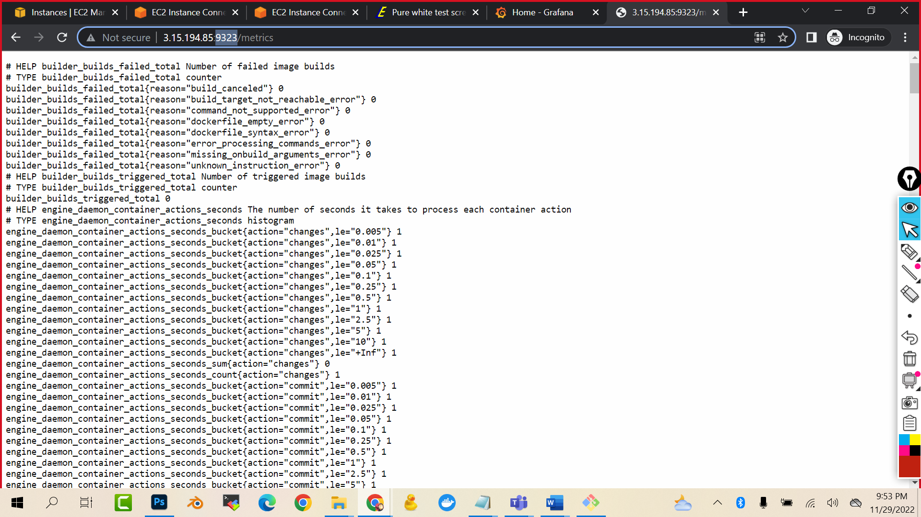

vi prometheus.yml

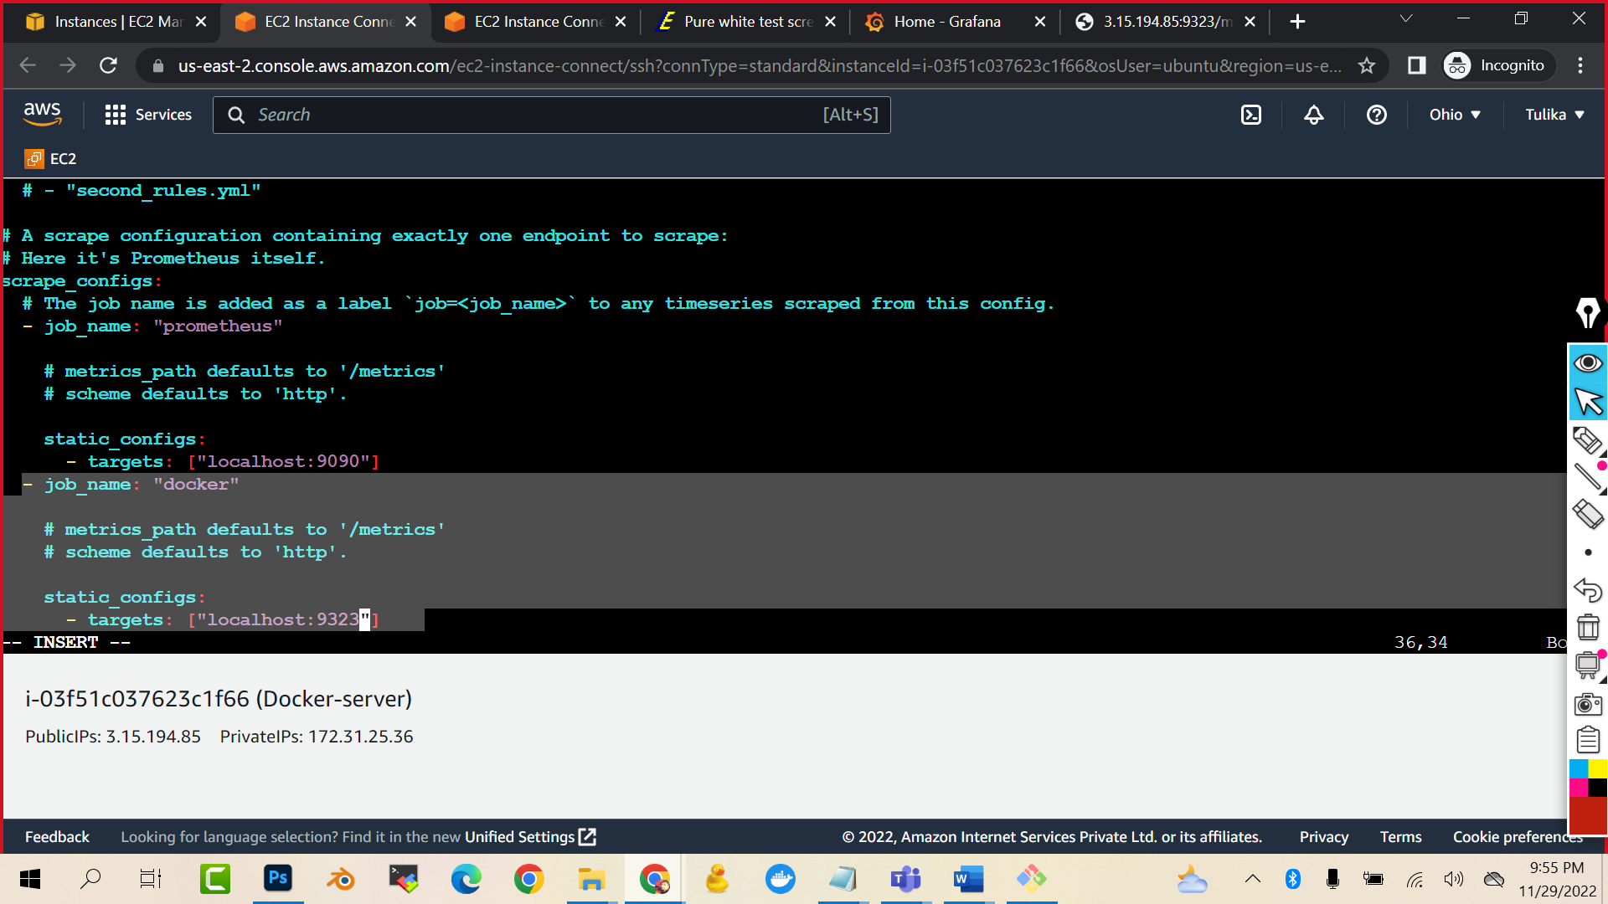

- job_name: "docker"

# metrics_path defaults to '/metrics'

# scheme defaults to 'http'.

static_configs:

- targets: ["localhost:9323"]

(just take care of one thing that – job_name should be exactly the job_name of the Prometheus)

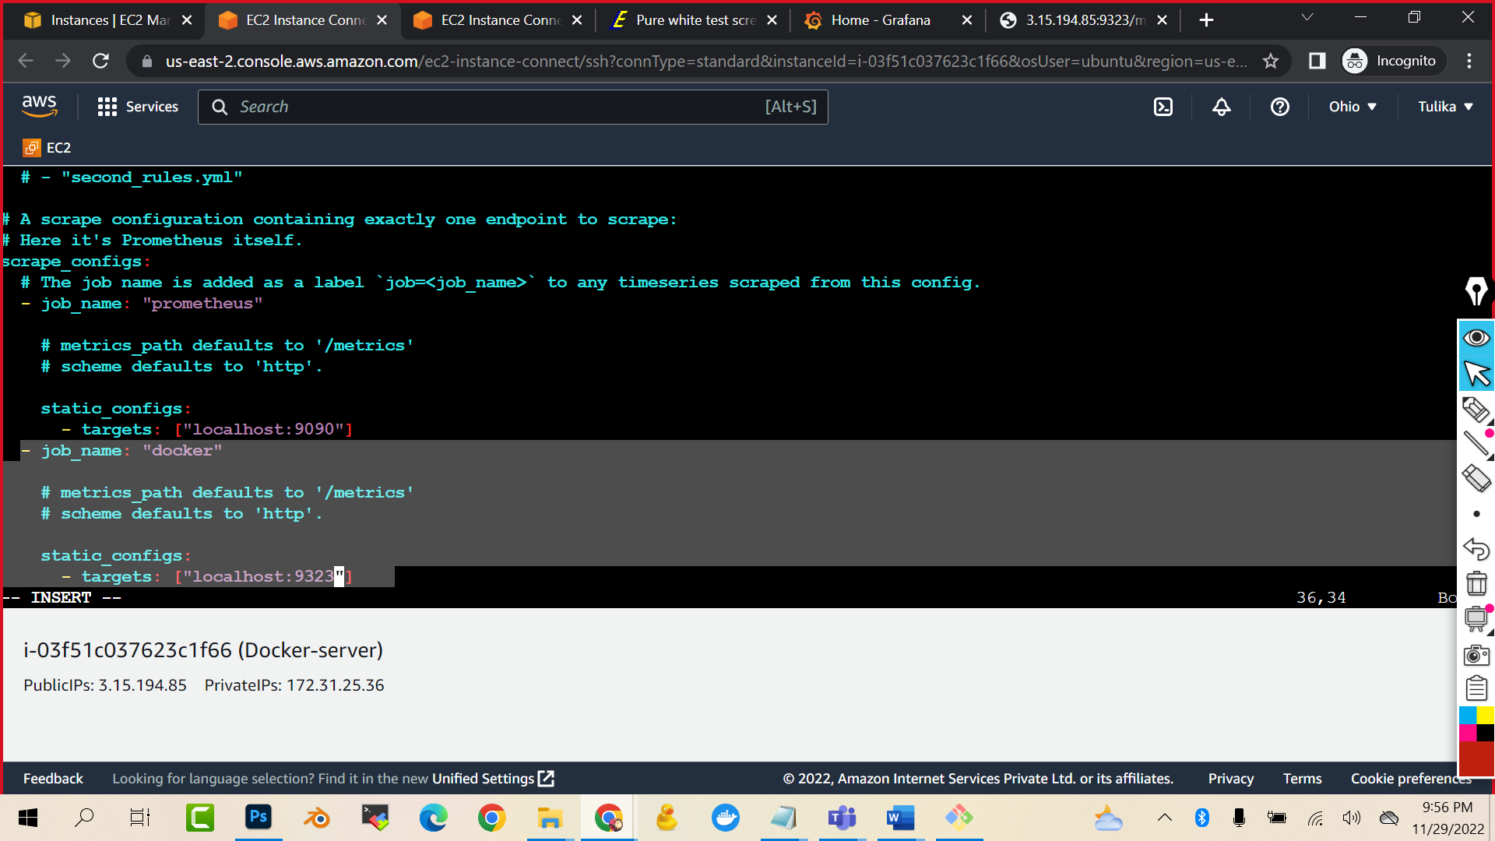



./prometheus (this will start the prometheus)

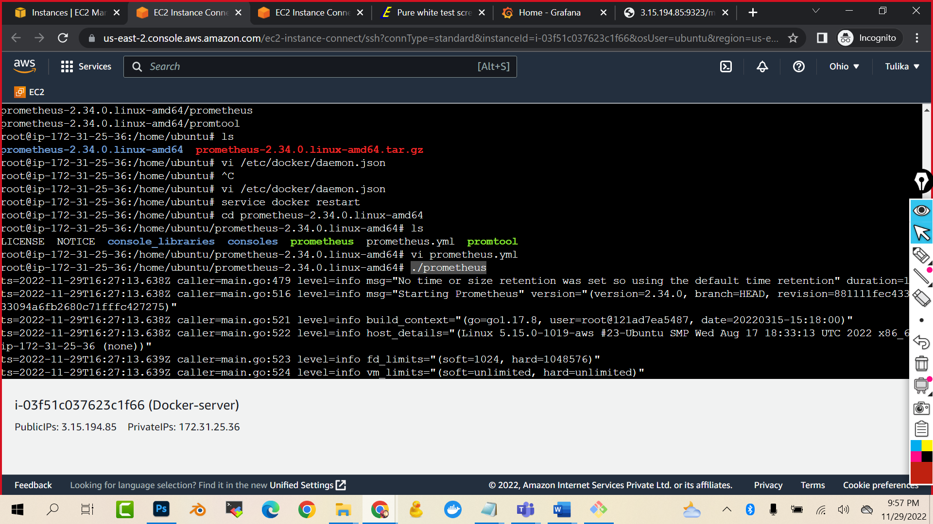

Now open public ip:9090 to check if Prometheus is opening or not

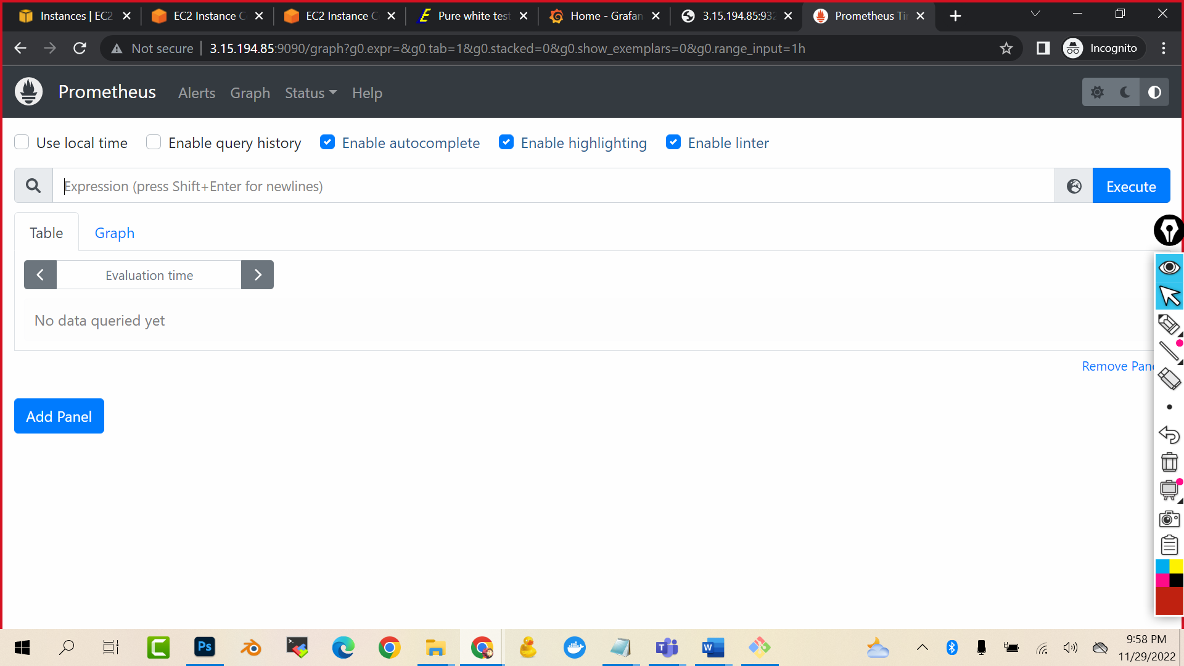

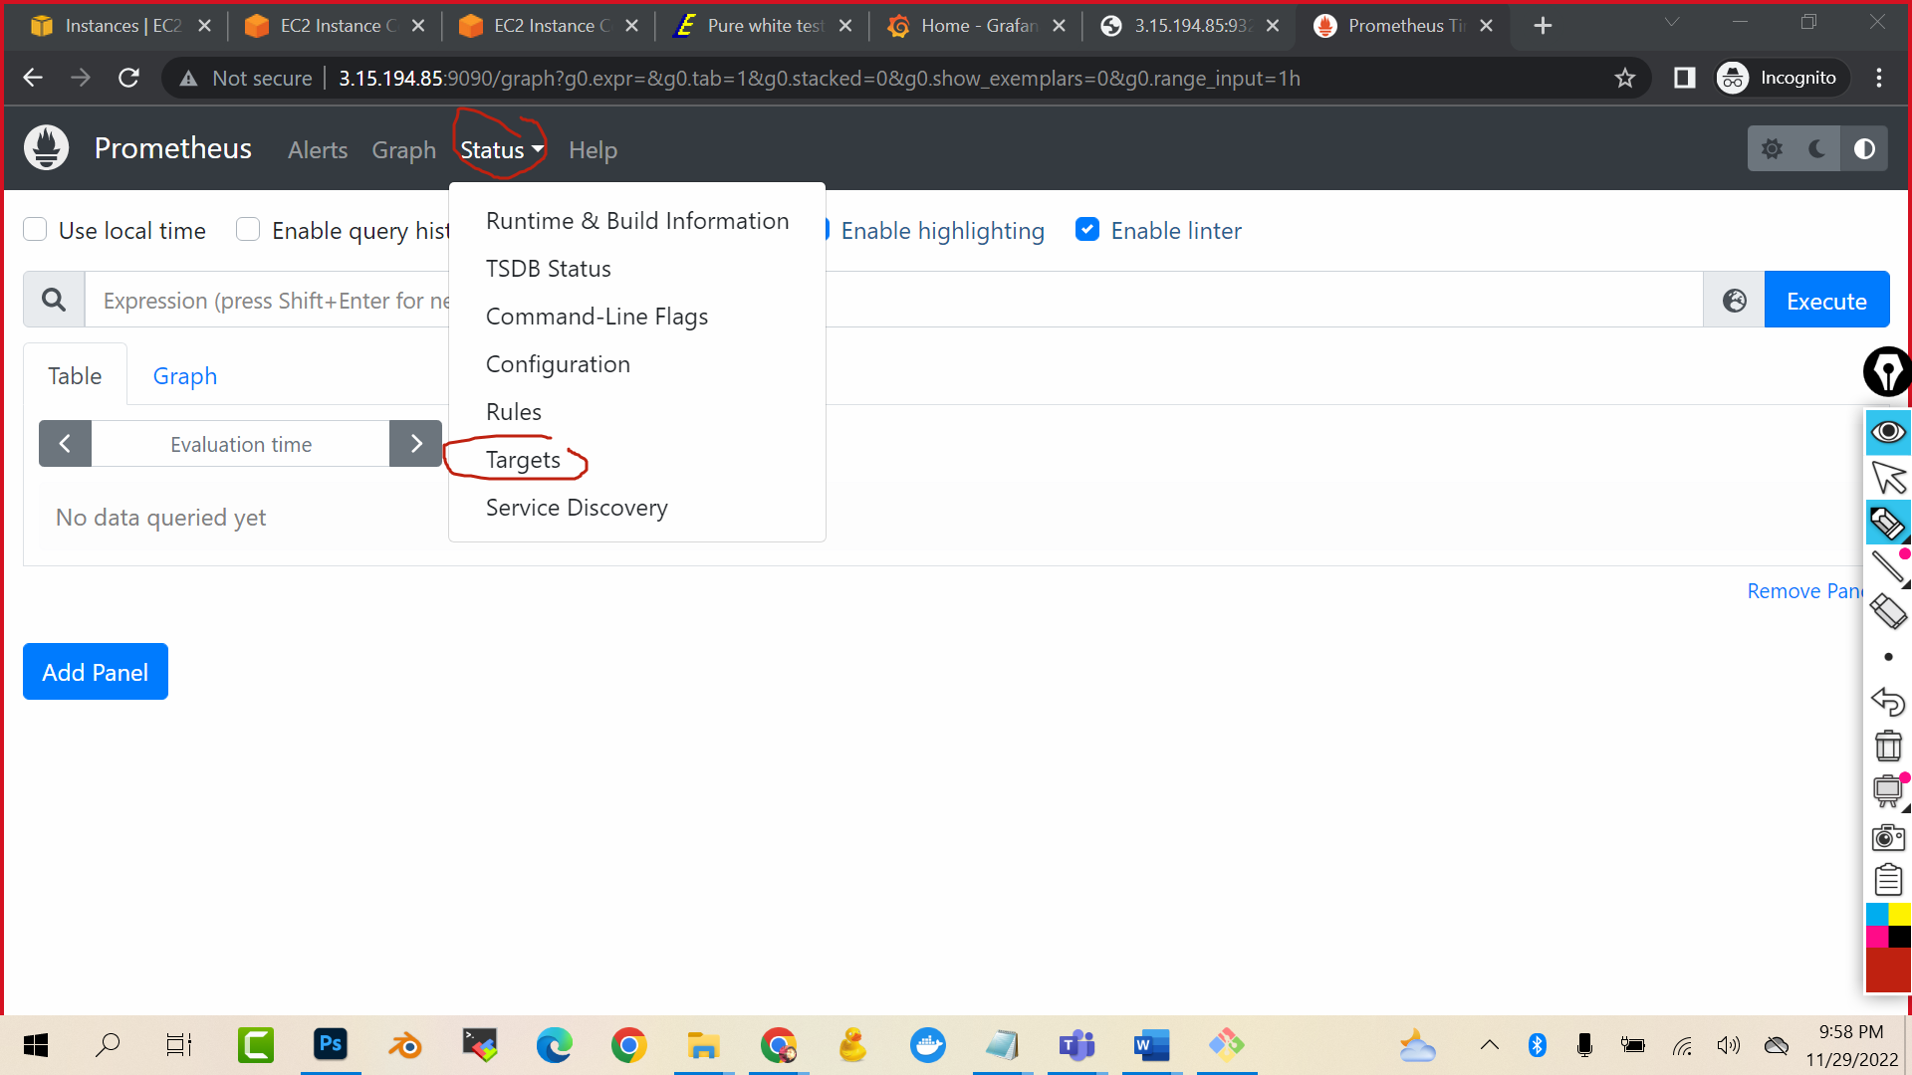

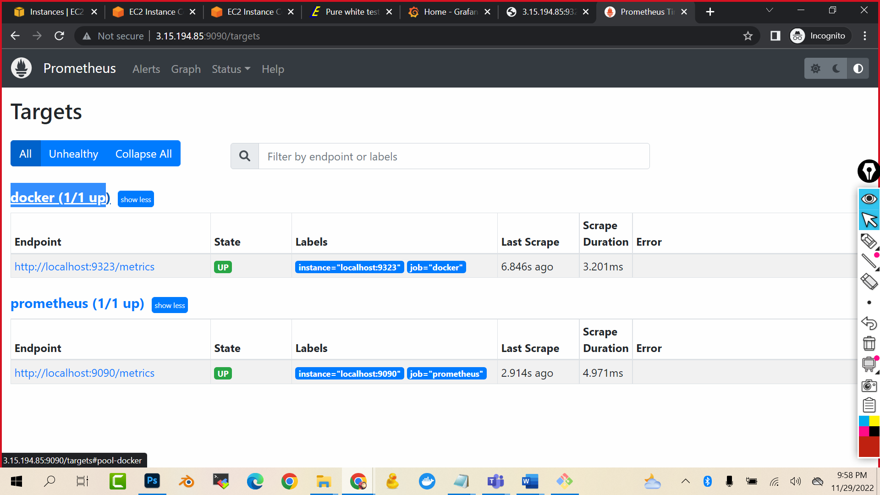

Now lets go to Grafana and we will 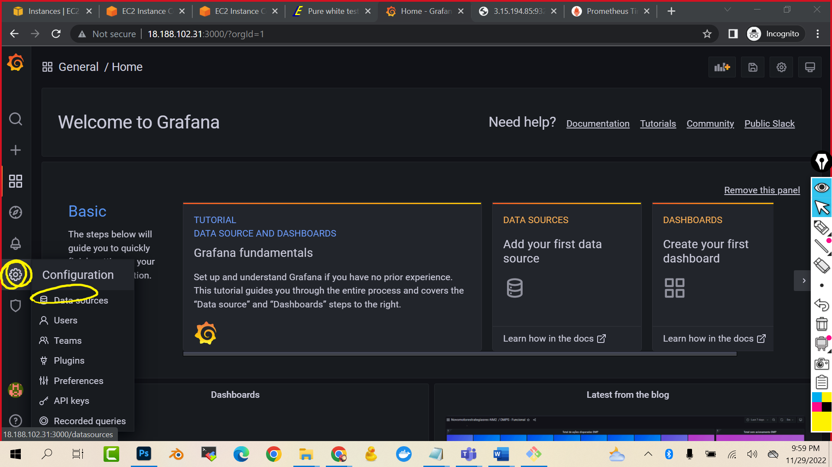give source as Prometheus to Grafana so that it can create beautiful graphs out of it

(select data sources)

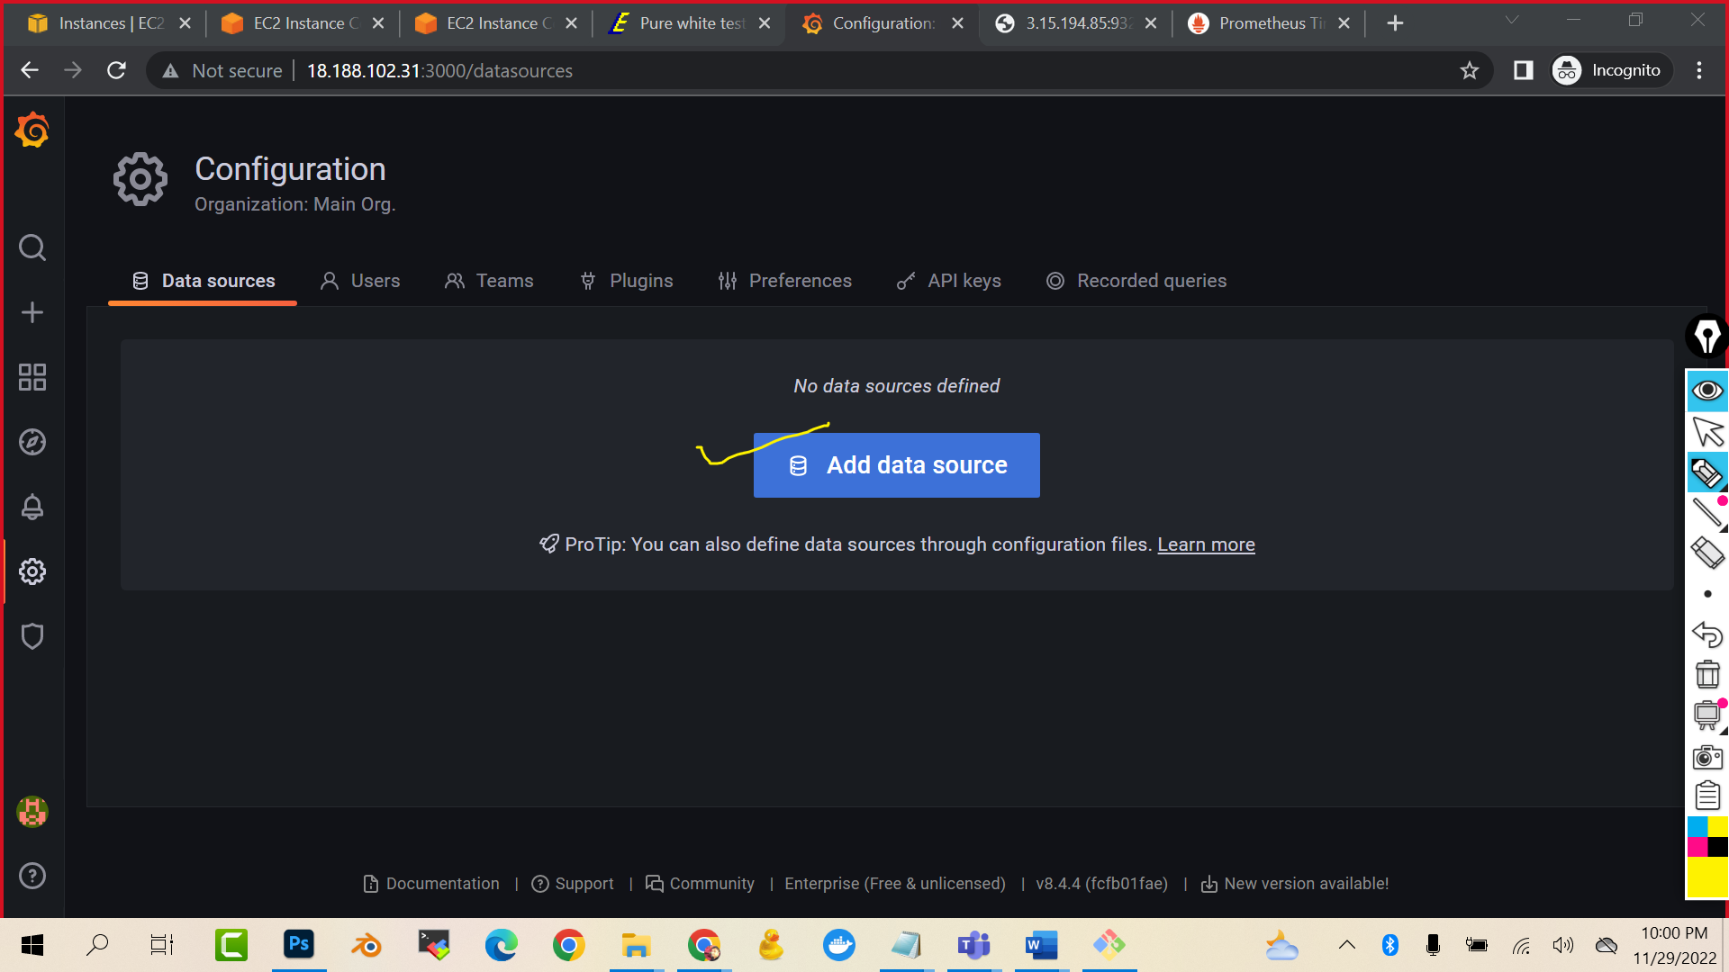

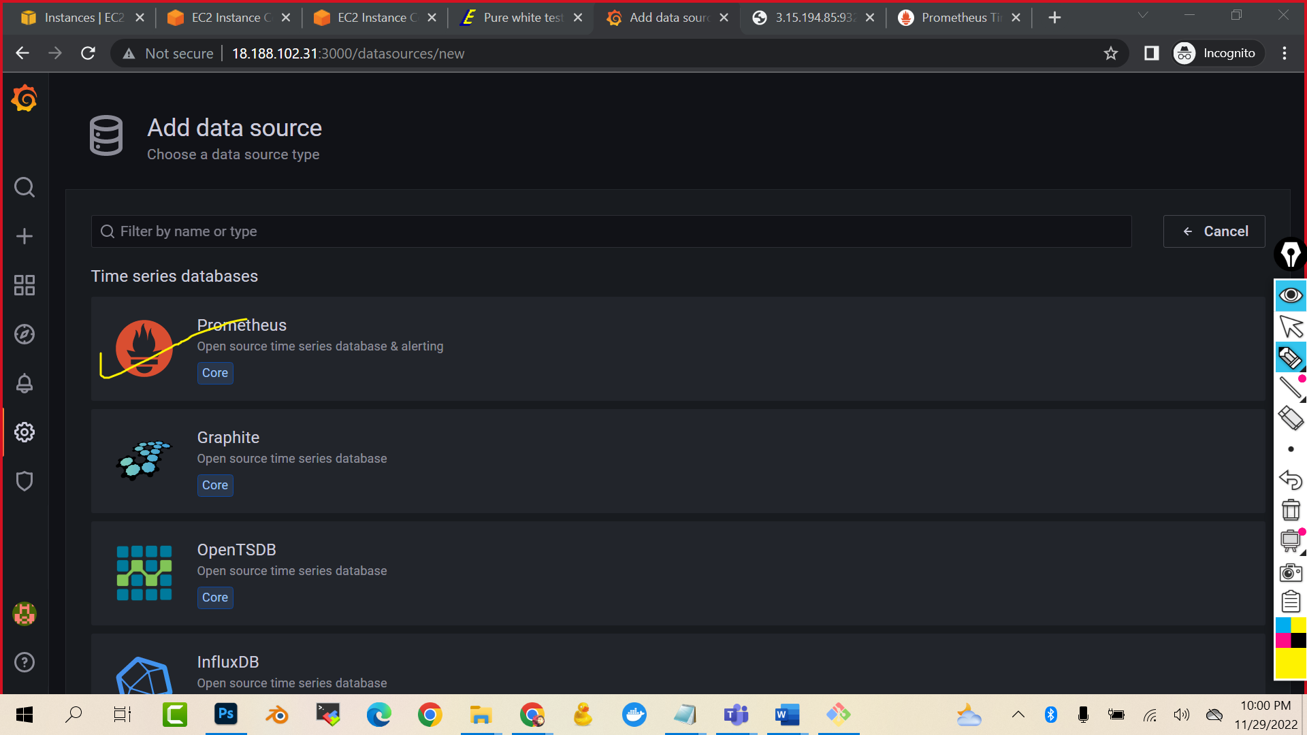

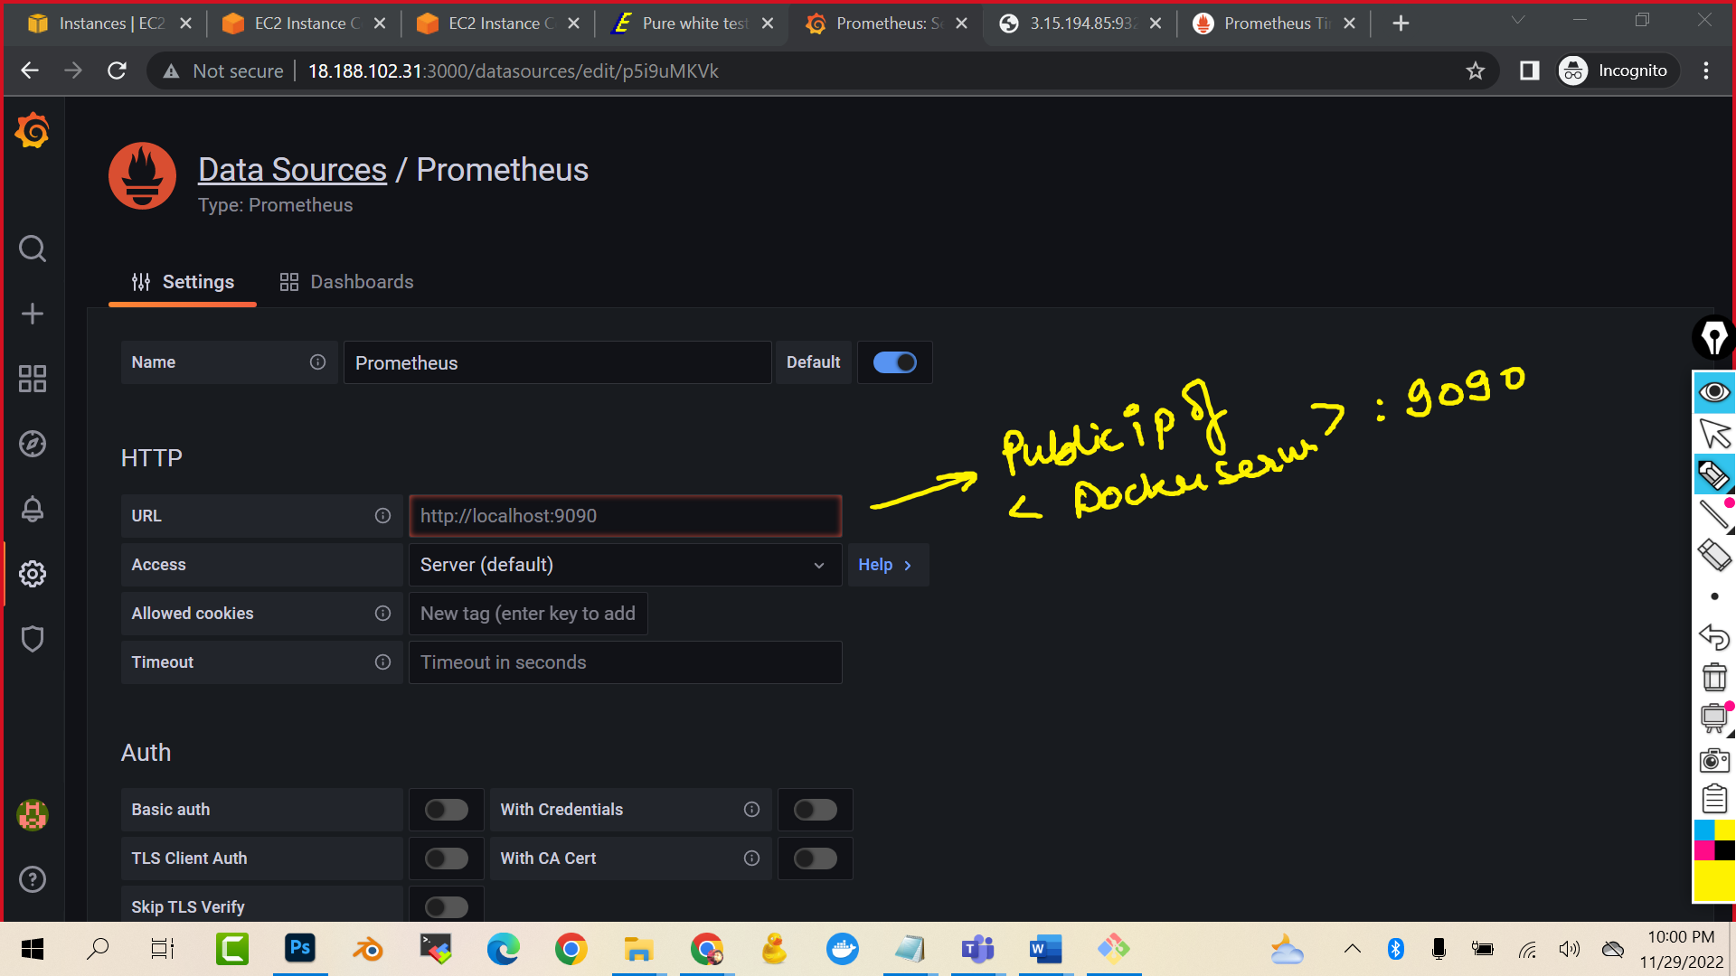

http://<ip address>:9090/

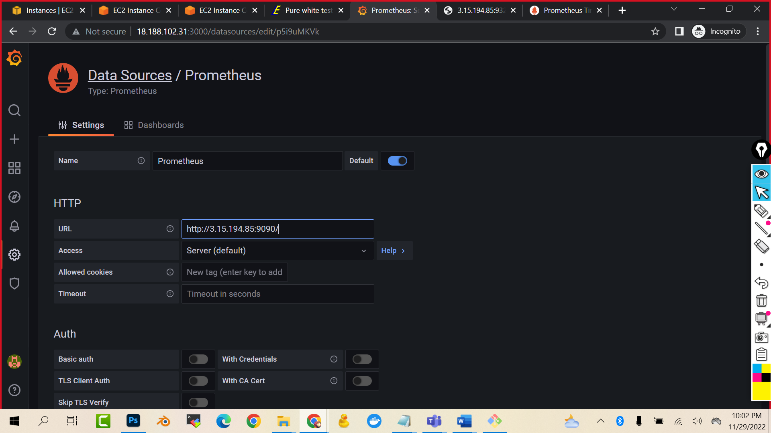

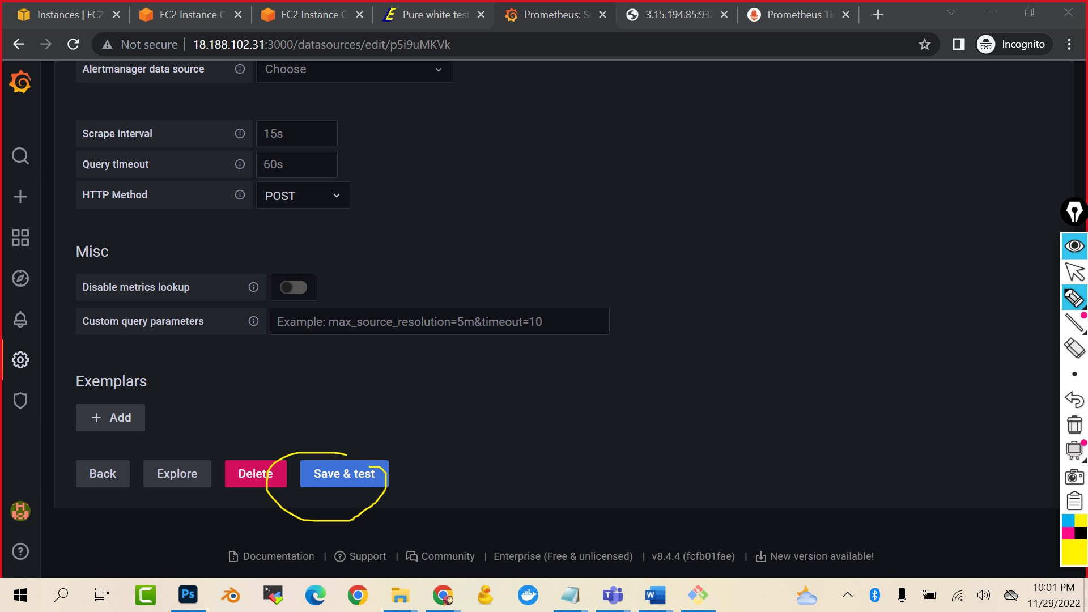

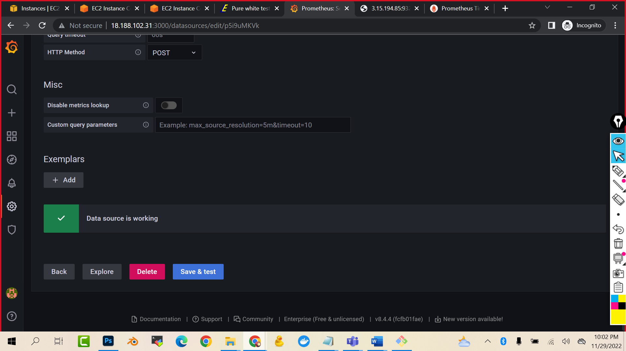

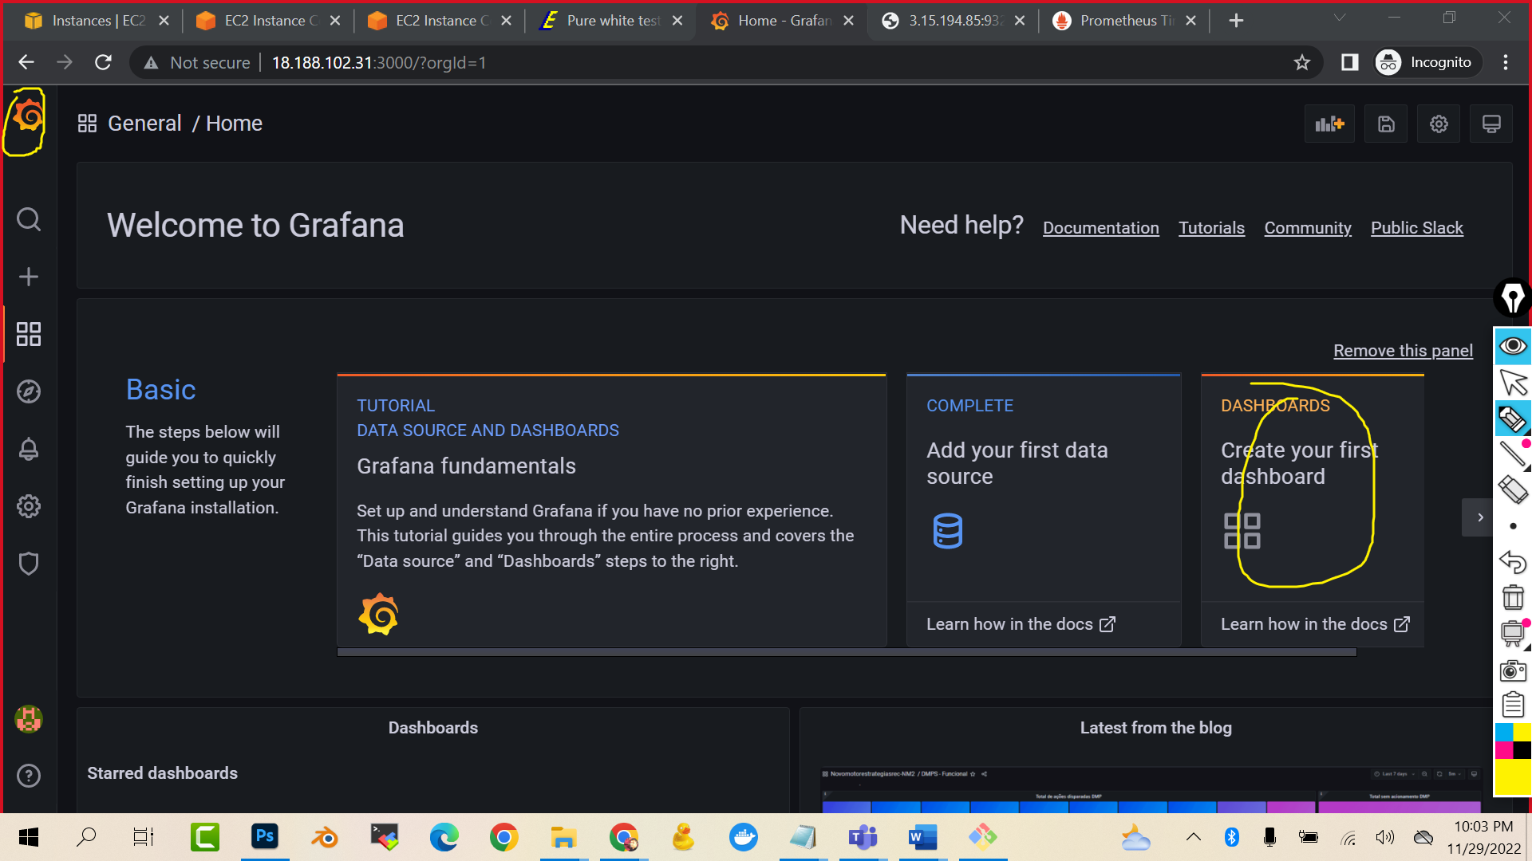

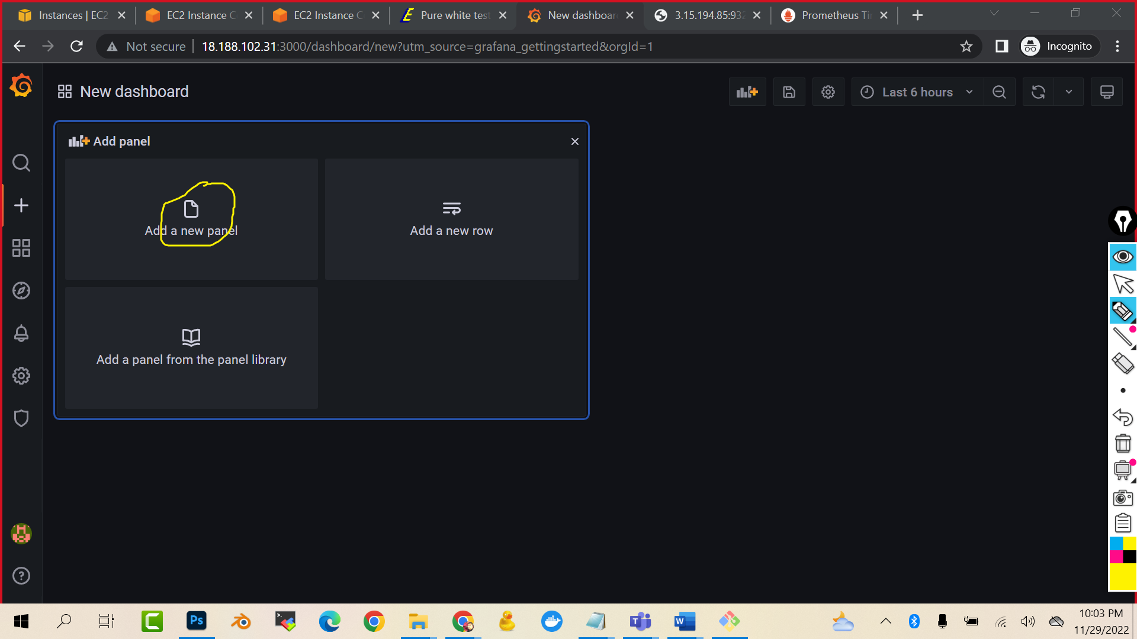

engine_daemon_container_states_containers{state="stopped"}

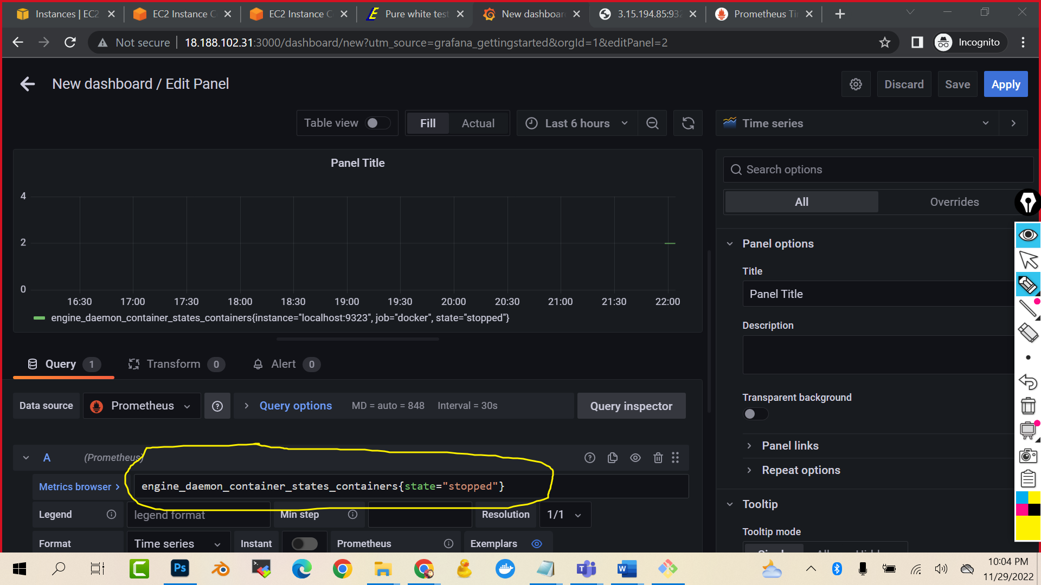

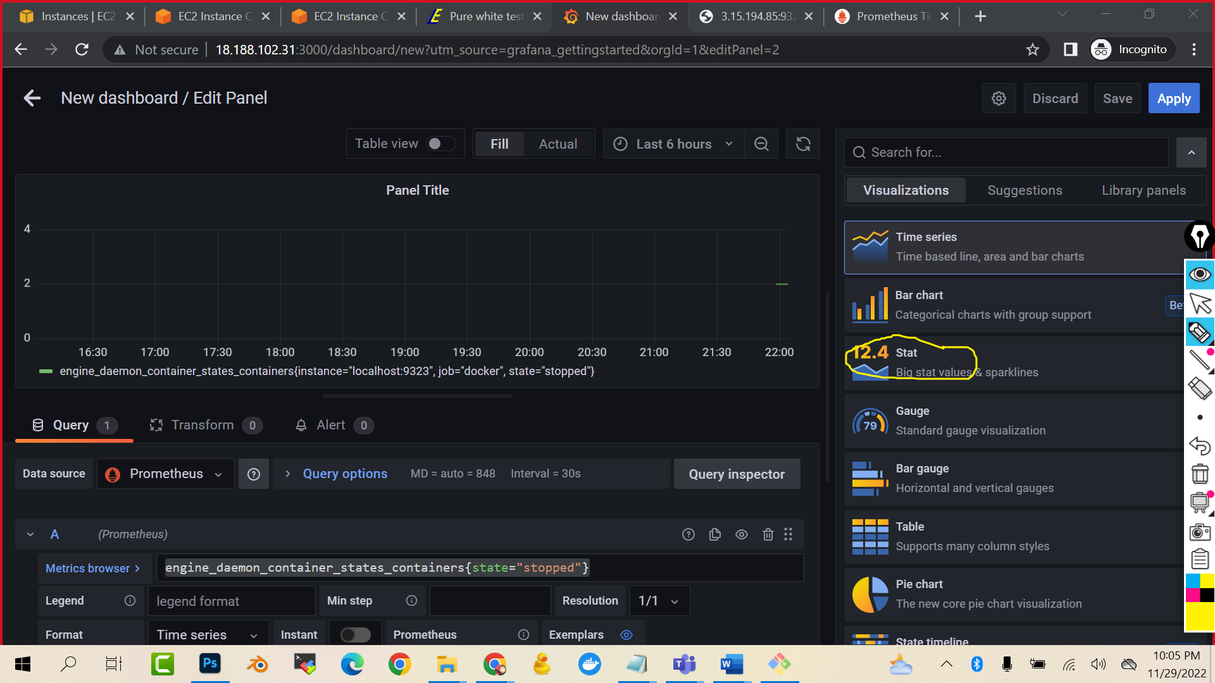

engine_daemon_container_states_containers{state="running"}

